**Learning activity 1 / *Actividad de aprendizaje 1***

**Evidence: My Profile / *Evidencia: Mi perfil***

Complete the blog entry with the appropriate information. / *Complete la entrada de blog, con la información correspondiente.*

Example / *Ejemplo:*

**Blog**

Name:



Hello Friends!

My name is Steve Jones. I am from United States. I am 31 years old. I am divorced. I am an electrician. I speak English. In my free time I read the newspaper and listen to music. My parents are Mary and Peter. They are from Canada. My dad is a carpenter and my mom is a housewife. I live in Miami. Thanks for reading my profile.



**Fuente:** SENA

Steve Jones



Your entry blog. / *Su entrada de blog.*

**Blog**

Name:



Hello Friends!

My name is Dickson. I am from Colombia. I am 31 years old. I am married. I am a engineer. I speak Spanish. In my free time I Study English. My parents are Moises and Angela. They are from Colombia. My dad is Accountant and my mom is a Teacher. I live in Colombia.

Dickson Garcia

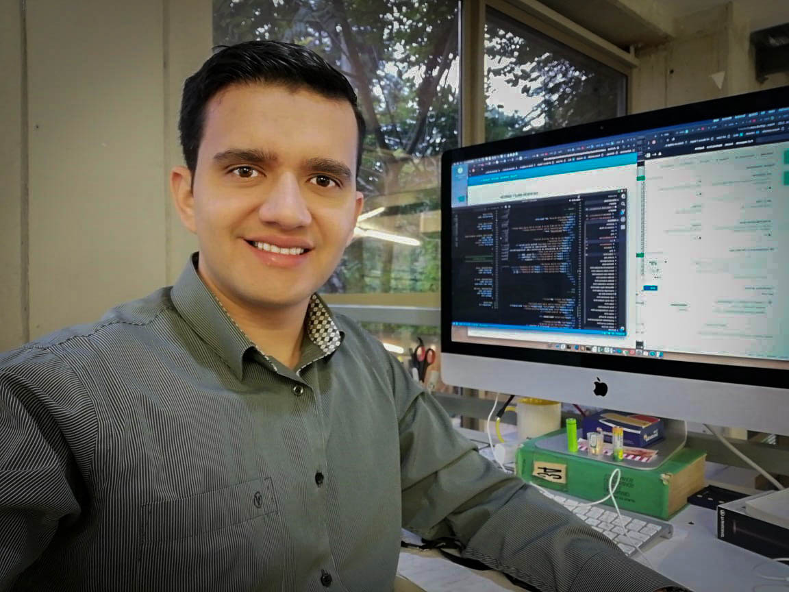

In the same entry of the blog, describe two family members. Include detailed information about them. / *En la misma entrada de blog, describa dos miembros de su familia. Incluya información detallada sobre ellos.*

Example / *Ejemplo:*

**Blog**

Name:



I have a brother. His name is Juan. He is a lawyer. He is 38 years old and he is divorced.

I have a sister. Her name is Andrea. She is 19 years old. She is a student and she is single.

Steve Jones

When you finish your work, send the file to your instructor through the platform as follows:

1. Click on the title of this evidence.
2. Click on *Examinar mi equipo* and look for the file in your computer. Make sure the file is attached.
3. Leave a comment for the instructor (optional).
4. Click *Enviar*.

*Una vez finalice la evidencia envíe al instructor el archivo a través de la plataforma, así:*

1. *Dé clic en el título de esta evidencia.*
2. *Dé clic en el enlace Examinar mi equipo y busque el archivo en su computador. Asegúrese de adjuntar el archivo.*
3. *Escriba algún comentario si lo considera pertinente.*
4. *Dé clic en Enviar.*

|  |
| --- |
| ***Criterios de evaluación*** |
| * *Intercambia información personal relacionada con profesiones.* * *Usa los artículos* a/an/theand zero *con la estructura y el vocabulario requeridos.* * *Usa los pronombres y adjetivos posesivos con la estructura y el vocabulario requeridos.* |